Accreditation Standards Review - Phase 1 Consultation
The Australasian Veterinary Boards Council (AVBC)'s Veterinary Schools Accreditation Advisory Committee (VSAAC) is reviewing the approved accreditation standards for entry-level veterinary programs (available for download here).

The standards are used by Council Members to evaluate veterinary education and training programs which lead to general registration in Australia and New Zealand. The purpose of the review is to ensure that accreditation standards continue to evolve and ensure that veterinary graduates are able to achieve Day One Competences to practice safely and sustainably, demonstrating the professional knowledge, skills and attributes required.

To assist in this process, we are seeking initial stakeholder comment on the drivers shaping the review. The Task Group is considering recent developments in accreditation adopted by the Royal College of Veterinary Surgeons (RCVS) (UK), which is a major accreditation partner with a mutual recognition agreement in place with the AVBC. These include reorganisation of the existing 12 standards into 6 domains, and a shift towards a more outcomes-focused and risk-based approach to accreditation of veterinary programmes. The new RCVS Accreditation Standards are available here.

Your perspectives and suggestions are invited on a series of questions relating to the current AVBC standards, the new RCVS Accreditation Standards and veterinary education more broadly.

The survey is broken into 3 parts (you may choose to skip sections):

- Current AVBC Accreditation Standards (Q. 3-5)

- New RCVS Accreditation Standards (Q. 6-10)

- The broader context for veterinary education (Q. 11-15)

The survey will take between 15-40 minutes to complete.
Please use dot points where possible in your responses.
Further consultation is planned as the review progresses throughout 2022.

Introduction
- We want to ensure that we are reaching all stakeholders of veterinary services and veterinary education. Please select your sector from the list below. You can choose more than one.

☐ Private Practice (Veterinarian)

☐ Private Practice (Veterinary Nurse/Technician)

☐ Veterinary Student

☐ Education

☐ Research

☐ Registration Board

☐ Professional Organisation

☐ Government

☐ Veterinary Industry

☐ Other

2. Organisation/Company (optional)

Click or tap here to enter text.

Part 1: Current AVBC Accreditation Standards
3, Do you have any comments on the current AVBC Standards? Can you identify problems or difficulties with the existing standards? Are there particular strengths?

Click or tap here to enter text.

4. Are there any standards that should be added/expanded, or any that should be deleted or combined?

Click or tap here to enter text.

5. Any other general comments about the current AVBC Standards?

Click or tap here to enter text.

Part 2: New RCVS Accreditation Standards

The new RCVS Accreditation Standards will come into effect in January 2023. The latest version can be downloaded here.

The AVBC is keen to hear your view on whether some key changes identified by the RCVS should be considered for the accreditation system for Australia and New Zealand.

Extracts included in this section have been accessed from a report in RCVS Council papers, November 2021: RCVS consultation on proposals for new accreditation standards and accreditation methodology for veterinary programmes. Results Report 2021.

6. Inputs vs outcomes

RCVS: The new approach to accreditation focuses less on ‘inputs’, which do not always necessarily provide strong assurance of quality, to focus increasingly on ‘outcomes’ or ‘process’ evidence, which more clearly demonstrate a positive impact or outcome (p. 76).

Would you support a similar shift in focus in the AVBC Standards?

Click or tap here to enter text.

7. A risk-based approach

RCVS: Our new approach is also risk-based, meaning that where an established school collates strong outcomes evidence on a longitudinal basis, this can be considered in advance and result in a ‘lighter touch’ visitation by the accreditation panel, which focuses only on the areas where there are gaps in evidence, or triangulation is needed, or physical resources need to be seen (p.76).

Do you support a risk-based approach to accreditation?

Click or tap here to enter text.

8 A ‘living’ accreditation rubric

RCVS: Accreditation panels typically work with a ‘rubric’ which lists the standards and evidence gathered to support each of them, and this translates into the recommendations in the report. In efforts to maintain objectivity, this rubric has become increasingly prescriptive, detailing the exact evidence which is needed to meet the standard. However, this often leads to problems when trying to apply it across increasingly varied models of curriculum and programme delivery – evidence suitable from a traditional programme model may be different to that from a distributed model, but both appropriate to demonstrate quality in a specific area. It can also lead to ‘double jeopardy’ where a lack of evidence can result in deficiencies being reported across more than one standard, which may give an unnecessarily negative impression.

RCVS: The new approach also includes an accreditation rubric, which will be a ‘living document’ used by the accreditation panel to monitor evidence gathered (both in advance in a repository and subsequently at the visitation). This will also support the ‘risk-based’ dynamic of the process – where substantial outcomes- based and triangulated evidence is available to the accreditation panel in the repository at the start of an accreditation event, the panel may consider this to be sufficient to have met the standard without the need to gather further information in this area at the visitation. The new rubric will also help ensure the transparency of the decision-making process, as the evidence used by the accreditation panel will be clear to the committees making the decisions on accreditation outcomes (p.76).

Do you support this approach to an accreditation rubric?

Click or tap here to enter text.

9. Classification of Standards into 6 Domains

The RCVS’ new Accreditation Standards have been classified into 6 domains (p.75).

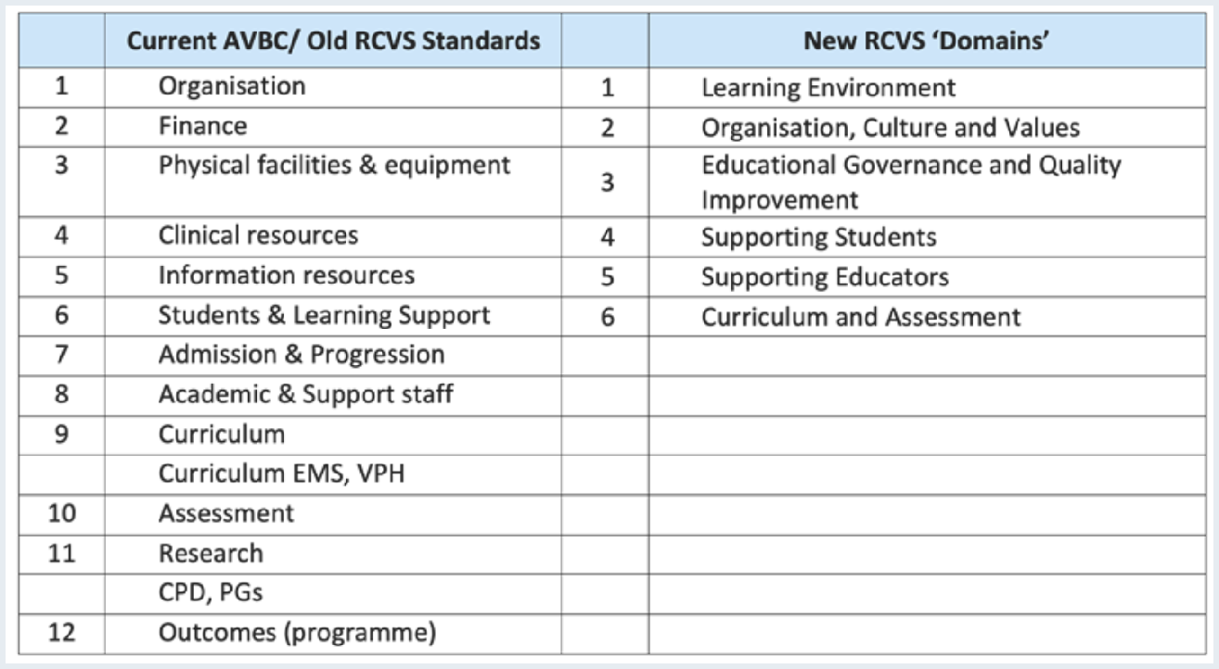

Should the AVBC adopt a similar framework?

Click or tap here to enter text.

10. Do you have any other comment on the new RCVS Accreditation Standards?

Click or tap here to enter text.

Part 3: The broader context of veterinary education
11. Looking to the future of the veterinary profession over the next 5 – 10 years, considering recent developments in practice, and the experience of new graduates, what do you consider to be the key implications for AVBC’s new standard? You can choose more than one option.

☐ Major focus on common conditions in primary veterinary care

☐ Safe practice in the community, incorporating cultural and social safe practice

☐ Student wellbeing, transition to practice and professional sustainability

☐ Emerging technologies in veterinary education and practice

☐ Professional responsibilities for animal welfare advocacy and education

☐ Advanced and continuing veterinary education

☐ Innovative and collaborative models for veterinary education

☐ Other

12. What do you believe should be the top 5 areas where a change in emphasis is needed in veterinary education over the next 7 years?

Click or tap here to enter text.

13. What does competency-based education offer to accreditation?

Click or tap here to enter text.

14. Are there any other issues that you think the Standards Review Task Group should consider within the review?

Click or tap here to enter text.

Conclusion
15. Please use the space below to share any additional ideas, suggestions or feedback you have.

Click or tap here to enter text.

Thank you for your participation. Please save this document with a new name and email it to standardsreview@avbc.asn.au

To receive updates from AVBC about the Standards Review, please add your email address below:
Click or tap here to enter text.

